Test Report
for
Brew Day!
Guo Rui 1630013011
Ji Jia 1630003023
Xie Qizhou 1630003056
Chen Mingxuan 1630003002
Atanasoff
19:55 2019/05/12
Contents
1. Brief description 1
2. Test date and performer 1
3. References 1
4. Error report 1
5. Appendix 1

Brief description
The testing time of ‘recommend’ features on 2019/5/13

Test date and performer
Date: 2019/5/13, test name is test recommend in brew.

References
Test_plan_Atanasoff.docx

Error report

Test case ID | Expected result | Actual result
D2_1 | Give error message about the ingredient size | Give some warning and not about ingredient size

Appendix
(On next page)

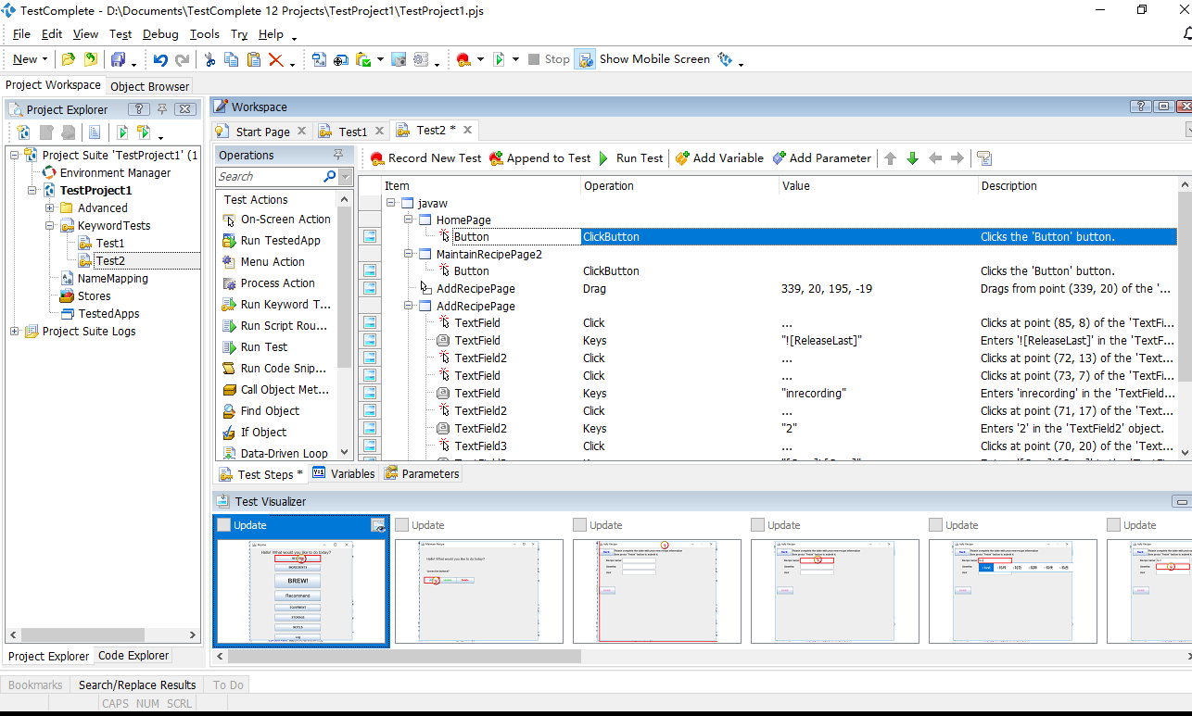

Figure 5.1

This is the control panel of the TestComplete, in this window we already record the script of testing.

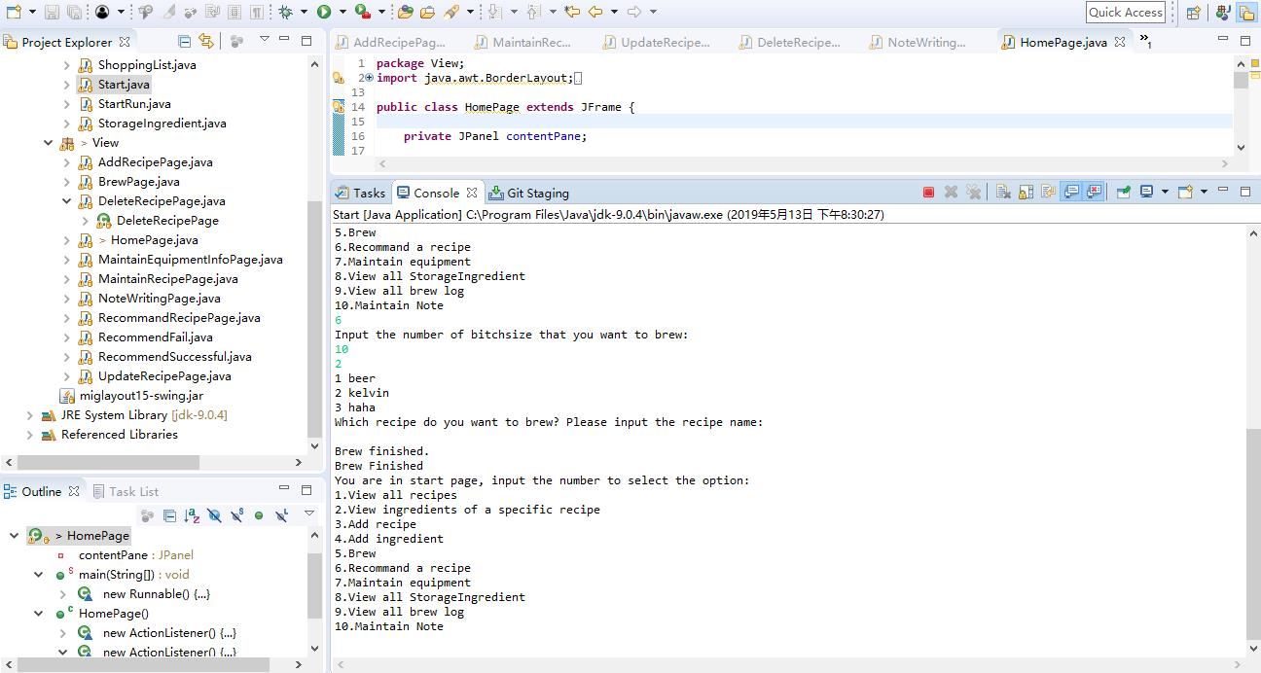

Figure 5.2
The script testing the code automatic, we can see it in Console window, print by the operation log.

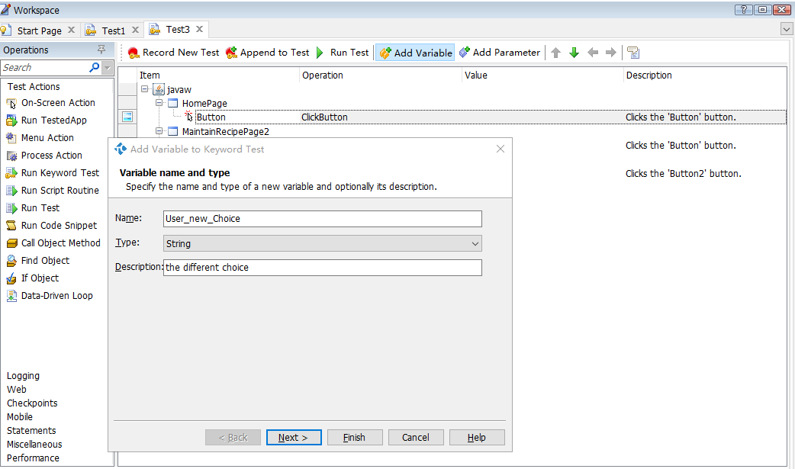

Figure 5.3
In this window, we add new Variable to change the user choice during the test.
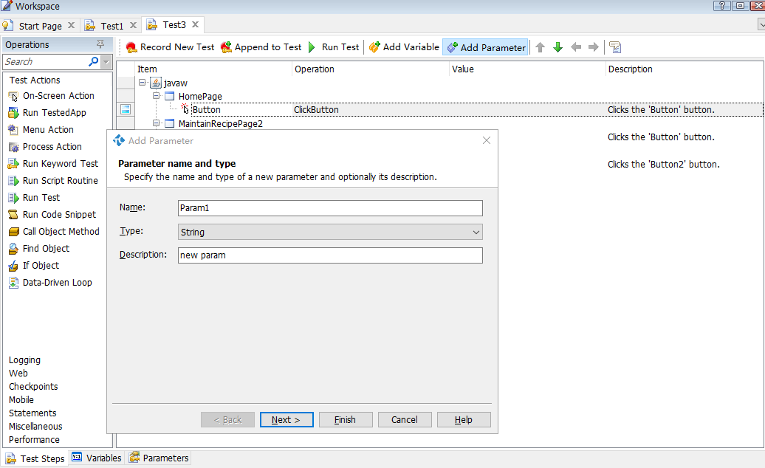

Figure 5.4
In this window, we add new Parameter to change the user choice during the test

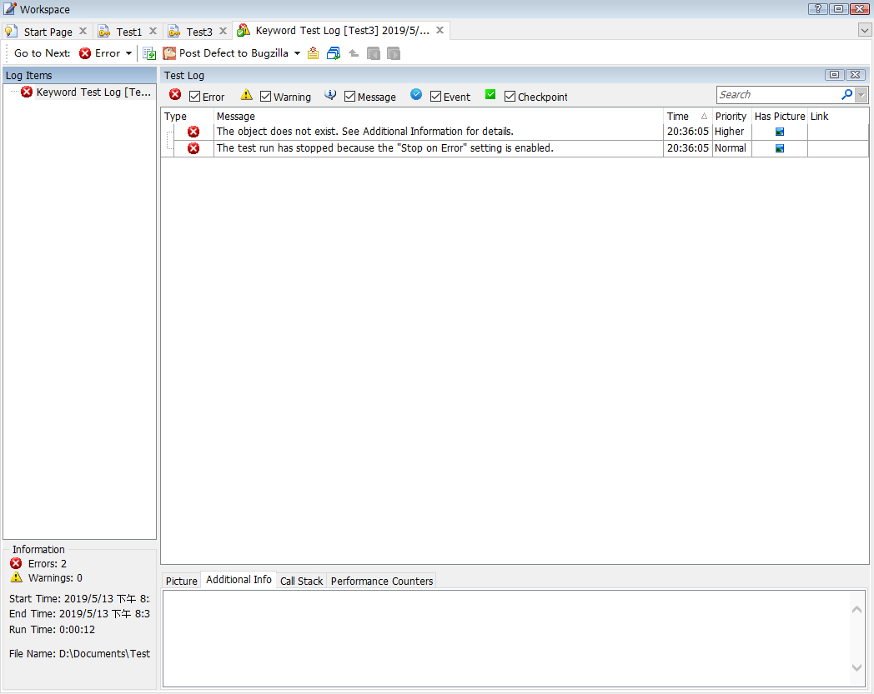

Figure 5.5
There are some Errors during the test, and the Test log told us.
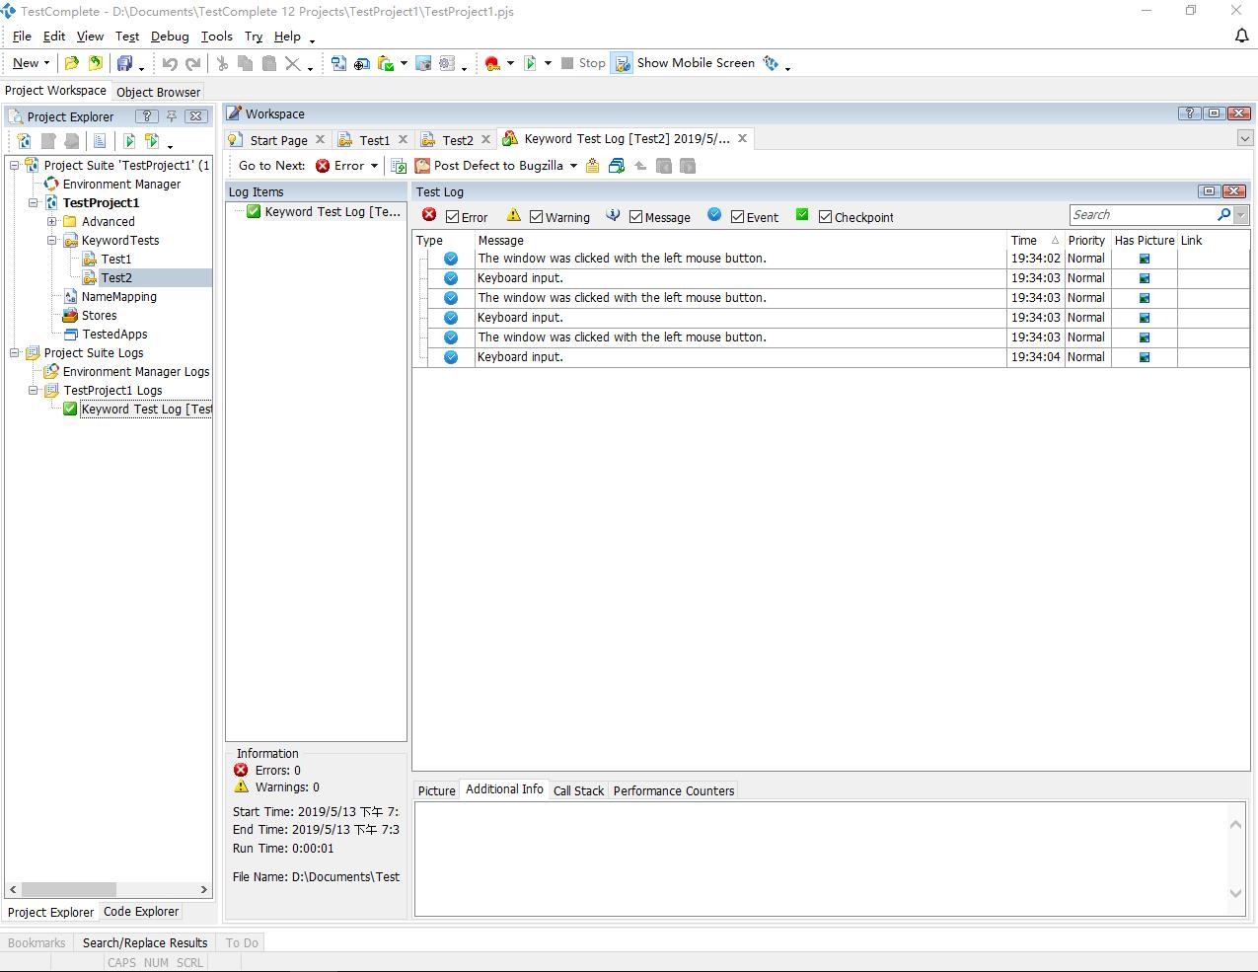

Figure 5.6
After the whole test, fix the error and get the nice result of testing

